**Assignment No. – 3**

**VLAN**

* Aim –

To configure a network for 3 VLANs

* VLAN –

VLANs (Virtual LANs) are logical grouping of devices in the same broadcast domain. VLANs are usually configured on switches by placing some interfaces into one broadcast domain and some interfaces into another. VLANs can be spread across multiple switches, with each VLAN being treated as its own subnet or broadcast domain. This means that frames broadcasted onto the network will be switched only between the ports within the same VLAN.

A VLAN acts like a physical LAN, but it allows hosts to be grouped together in the same broadcast domain even if they are not connected to the same switch. Here are the main reasons why you should use VLANs in your network:

* + VLANs increase the number of broadcast domains while decreasing their size.
  + VLANs reduce security risks by reducing the number of hosts that receive copies of frames that the switches flood.
  + You can keep hosts that hold sensitive data on a separate VLAN to improve security.
  + You can create more flexible network designs that group users by department instead of by physical location.
  + Network changes are achieved with ease by just configuring a port into the appropriate VLAN.
* Method –

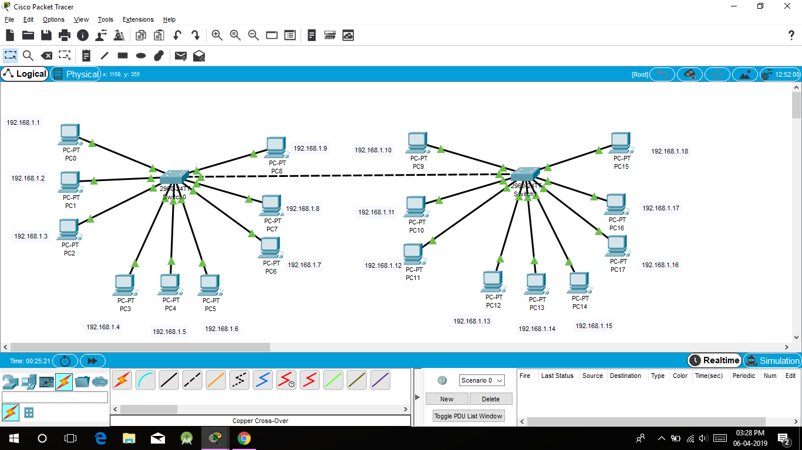

* Commands for Switch 1 –

Switch>en

Switch#conf t

Switch(config)#int fa0/1

Switch(config-if)#switchport access vlan 10

Switch(config-if)#no shut

Switch(config-if)#exit

Switch(config)#int fa0/2

Switch(config-if)#switchport access vlan 10

Switch(config-if)#no shut

Switch(config-if)#exit

Switch(config)#int fa0/3

Switch(config-if)#switchport access vlan 10

Switch(config-if)#no shut

Switch(config-if)#exit

Switch(config)#int fa0/4

Switch(config-if)#switchport access vlan 20

Switch(config-if)#no shut

Switch(config-if)#exit

Switch(config)#int fa0/5

Switch(config-if)#switchport access vlan 20

Switch(config-if)#no shut

Switch(config-if)#exit

Switch(config)#int fa0/6

Switch(config-if)#switchport access vlan 20

Switch(config-if)#no shut

Switch(config-if)#exit

Switch(config)#int fa0/7

Switch(config-if)#switchport access vlan 30

Switch(config-if)#no shut

Switch(config-if)#exit

Switch(config)#int fa0/8

Switch(config-if)#switchport access vlan 30

Switch(config-if)#no shut

Switch(config-if)#exit

Switch(config)#int fa0/9

Switch(config-if)#switchport access vlan 30

Switch(config-if)#no shut

Switch(config-if)#exit

Switch(config)#int fa0/24

Switch(config-if)#switchport mode trunk

Switch(config-if)#no shut

Switch(config-if)#exit

Switch(config)#exit

Switch# copy run start

* Commands for switch 2 –

Switch>

Switch>en

Switch#conf t

Switch(config)#int fa0/1

Switch(config-if)#switchport access vlan 10

Switch(config-if)#no shut

Switch(config-if)#exit

Switch(config)#int fa0/2

Switch(config-if)#switchport access vlan 10

Switch(config-if)#no shut

Switch(config-if)#exit

Switch(config)#int fa0/3

Switch(config-if)#switchport access vlan 10

Switch(config-if)#no shut

Switch(config-if)#exit

Switch(config)#int fa0/4

Switch(config-if)#switchport access vlan 20

Switch(config-if)#no shut

Switch(config-if)#exit

Switch(config)#int fa0/5

Switch(config-if)#switchport access vlan 20

Switch(config-if)#no shut

Switch(config-if)#exit

Switch(config)#int fa0/6

Switch(config-if)#switchport access vlan 20

Switch(config-if)#no shut

Switch(config-if)#exit

Switch(config)#int fa0/7

Switch(config-if)#switchport access vlan 30

Switch(config-if)#no shut

Switch(config-if)#exit

Switch(config)#int fa0/8

Switch(config-if)#switchport access vlan 30

Switch(config-if)#no shut

Switch(config-if)#exit

Switch(config)#int fa0/9

Switch(config-if)#switchport access vlan 30

Switch(config-if)#no shut

Switch(config-if)#exit

Switch(config)#int fa0/24

Switch(config-if)#switchport mode trunk

Switch(config-if)#exit

Switch(config)#exit

Switch#copy run start

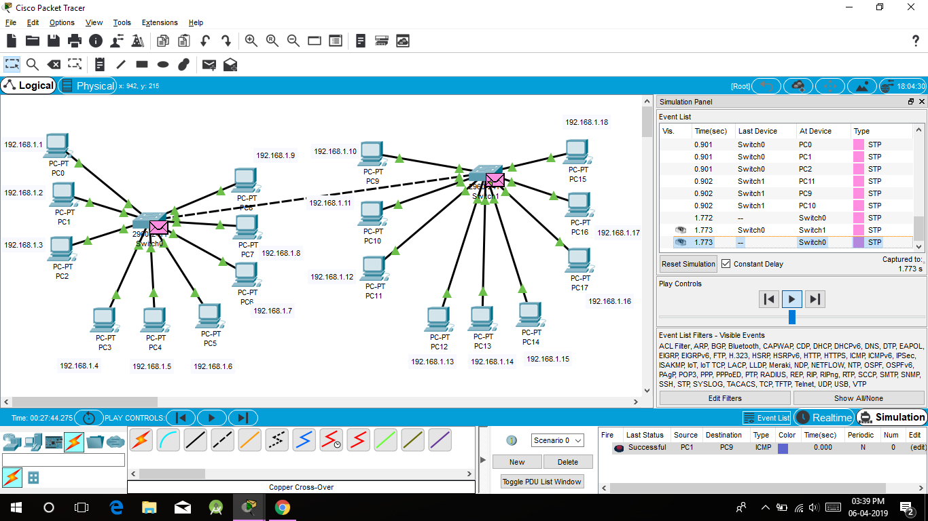

* Conclusion –

In this way, we have configured the network for 3 VLANs and established the communication.